**-FIR (finite impulse response) design**

In this part we want to design a FIR filter. Designin a DT filter with the same specification az those of the previous example.

In the first place we must calculate several parameters such as A,M, β and of course w[n] shape then we multiply to a *sinc* function then we have desire h[d] 

   
 

We chose the smaller. Because  satisfy the smaller ripple of problem specifications



α=M/2 and I0(.) is zero-order modified Bessel function of the first kind.

According to A magnitude β is 0.



If β=0 w[n] is rectangular

=12

Note: N is predicted to within ±2 over a wide range of ///// and A.

 

 



We change the M to m+2 to satisfy problem specification.

Test 1: by giving filter several signal with different frequency the filter passes signals with frequency between 0<f<.35 πbut in the 0<f<.275π the output is similar to the given signal the output of .276π<f<.35π otherwise filter will not let the signal to pass

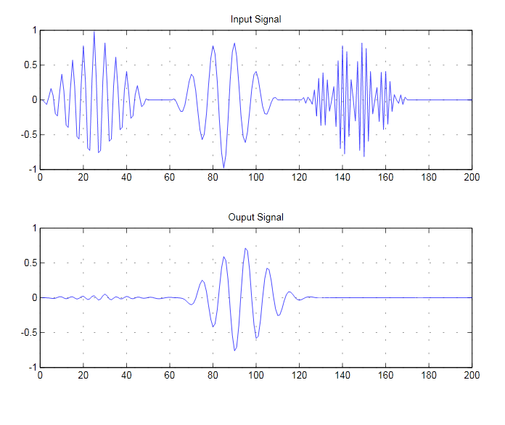

Test 2:by giving WGN the PSD(power spectral density )of output and magnitude response()

will have similar shapes



It is clear that PSD of WNG is became like and WN became CN (color noise) and frequency of CN mainly have cover bandwidth of filter

